

German University in Cairo

**Advanced Mechatronics (MCTR903)**

**Lab 1**

## Table of Contents

1. Install Windows Subsystem for Linux (WSL) 3

2. Install Visual Studio Codes (VS Code) 3

3. Problem 1 Description 4

4. Problem 1 Requirements 4

5. Submission Files 5

# Lab Objectives

# Install Windows Subsystem for Linux (WSL)

* + *In order to install Windows Subsystem for Linux (WSL) kindly following the below steps:*
    1. Update the Windows version as you must be running Windows 10 version 2004 or higher (build 19041 or higher) or Windows 11. To check the Windows version and build number, select from the keyboard **Windows logo Use your Apple Keyboard in Windows with Boot Camp - Apple Support + R** and type **winver** then select OK to know the version and to have the ability to update the current Windows version.
    2. Run Windows Command Prompt as administrator.
    3. Install WSL by typing in the Command Prompt **(wsl --install):**

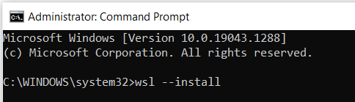

* + 1. By default the installed Linux distribution will be Ubuntu. However, you can ensure the distribution selection and that the download process of Ubuntu is done by typing in the Command Prompt **(wsl --install -d Ubuntu):**

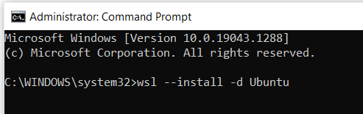

* + 1. During the installation, you will get to choose your Linux user password remember it well as you'll need it to install additional software.
    2. Now you will be able to see the Ubuntu application available on your Windows by typing Ubuntu in the start menu and you can open the application to start coding through Ubuntu:

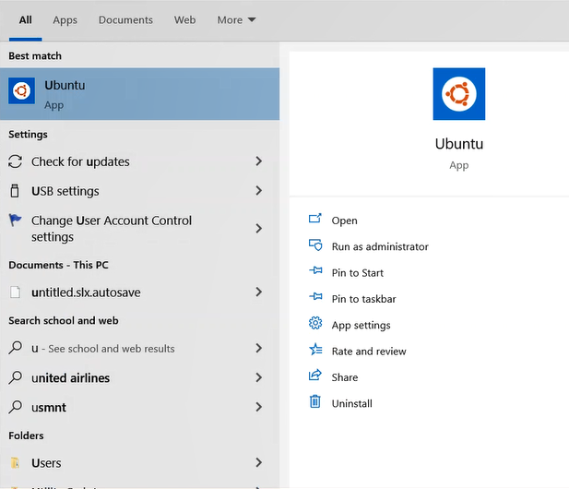

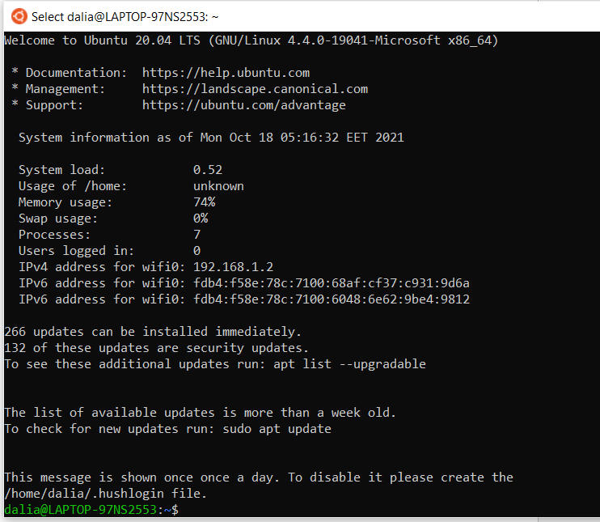

* + 1. You can manage the packages on Ubuntu by then. To update Ubuntu packages, type on Ubuntu terminal **(sudo apt update):**

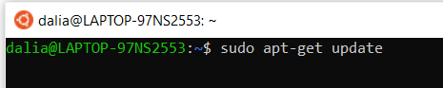

* + 1. You can further install any package required by typing on Ubuntu terminal **(sudo apt install <package_name>).**
    2. Resources to follow for the installation are listed below:
       - <https://ubuntu.com/wsl>
       - <https://wiki.ubuntu.com/WSL>

# Install Visual Studio Codes (VS Code)

* + *In order to configure Visual Studio (VS) Code to use C++ compiler on Ubuntu in the Windows Subsystem for Linux (WSL), we have firstly to install VS Code which has support for working directly in WSL with the help of Remote-WSL extension:*
    1. To download open source VS Code, download the Windows version through the following link: <https://code.visualstudio.com/download>.
    2. Install Remote – WSL extension which is required to connect WSL with VS Code through the following link: <https://marketplace.visualstudio.com/items?itemName=ms-vscode-remote.remote-wsl> which will require installing VS Code first and opening the VS Code to install the extension from it directly.
    3. Follow the instruction available through the following link carefully: <https://code.visualstudio.com/docs/cpp/config-wsl> to link WSL and VS Code and making a directory to be used for the project and installing the suitable complier tool and GDB debugger to be used next.
    4. After following the steps available on the previously mentioned link, install C/C++ extension from the following link which will navigate to VS Code for installation: <https://marketplace.visualstudio.com/items?itemName=ms-vscode.cpptools>